*Florida International University*

*School of Computing and Information Sciences*

Software Engineering Focus

Feature Document

User Story ID #663

**Name:** Kyle Ryan

**Team Member(s):** Mario Fidalgo

**Project:** Mobile Judge 9.0

**Product Owner(s)**: Masoud Sadjadi

**Mentor(s)**: Masoud Sadjadi

**Instructor**: Masoud Sadjadi

**User Story Name: Add combobox in students/judges tab for status**

**Description**

As an admin, I would like to have a combobox for the status column in the Judge & Student views in the people tab in order to quickly change the status.

**Acceptance Criteria**

* Combobox that includes all the possible statuses for Judges or Students.

**Use Case**

* Name: Change Status
* Actor: Admin
* Preconditions: User must be logged in as an admin and in the student or judge view of the people tab.
* Description <Flow of events>:

1. User double clicks on a student or judge

2. System makes fields editable

3. User selects desired status and clicks update

4. System makes changes to database

**Use Case Diagram**

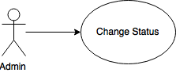

**Sequence Diagram**

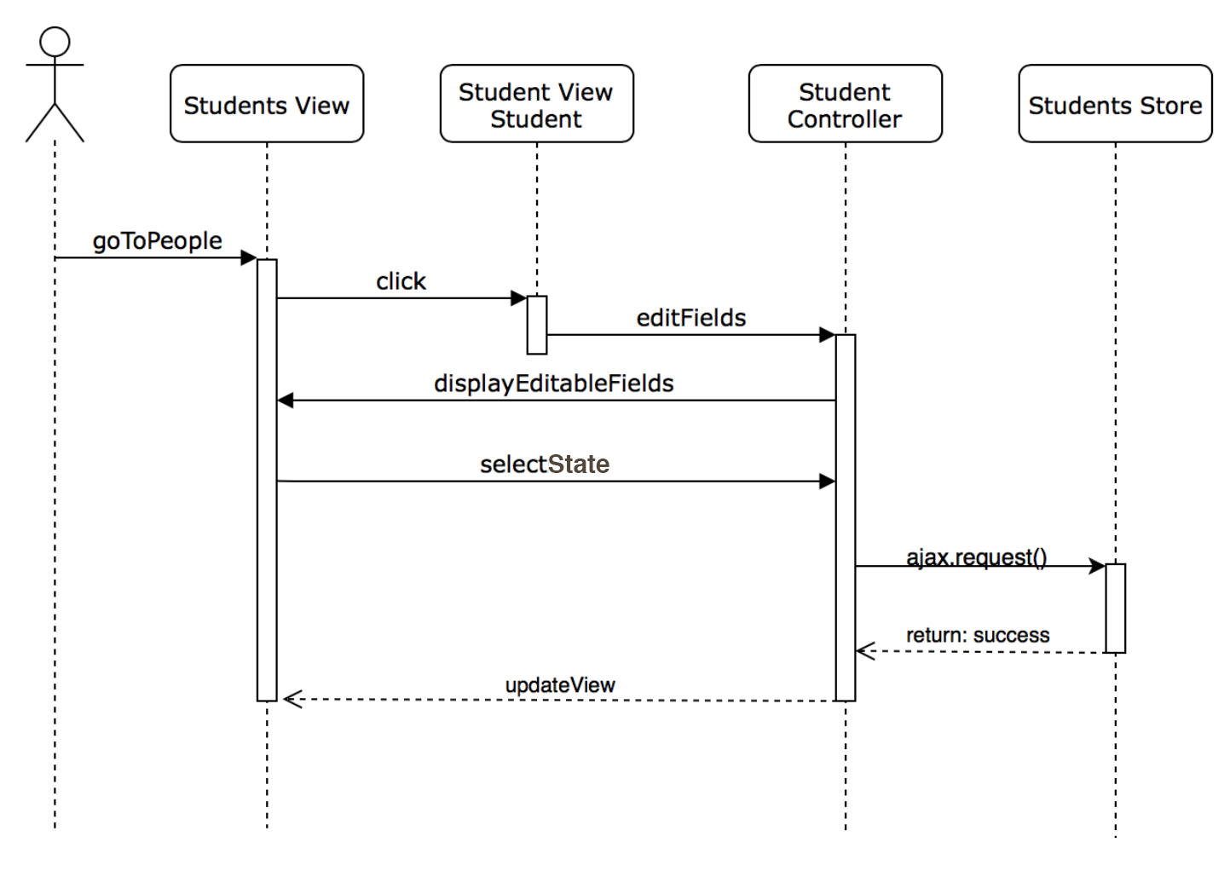

**Class Diagram**

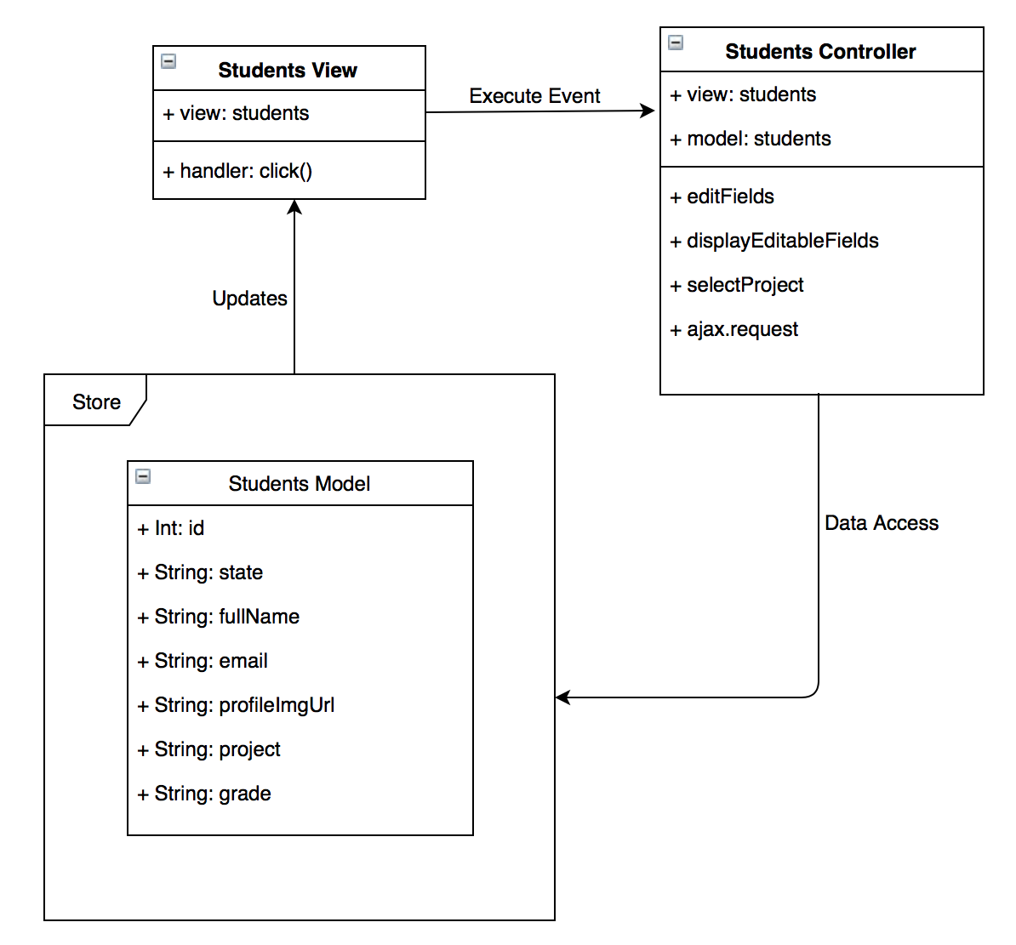

**Unit Test & Integration Test**

|  |
| --- |
| **Test case ID**: MJ-663-01  **Description/Summary of Test**: Change students state  **Precondition**:   * Admin is currently logged into Mobile Judge account * Currently on the people side tab * Viewing the students gridview * Selects a student and changes their state   **Expected Results:** The student’s state changes and saves.  **Actual Result:** The student’s state changed and saved.  **Status (Fail/Pass):** Pass |

|  |
| --- |
| **Test case ID**: MJ-663-02  **Description/Summary of Test**: Change students state  **Precondition**:   * Admin is currently logged into Mobile Judge account * Currently on the people side tab * Viewing the judges gridview * Selects a judge and changes their state   **Expected Results:** The judge’s state changes and saves.  **Actual Result:** The judge’s state changed and saved.  **Status (Fail/Pass):** Pass |